***University Physics Volume I***

**Unit 1: Mechanics**

**Chapter 10: Fixed-Axis Rotation**

**Conceptual Questions**

1. A clock is mounted on the wall. As you look at it, what is the direction of the angular velocity vector of the second hand?

Solution

The second hand rotates clockwise, so by the right-hand rule, the angular velocity vector is into the wall.

1. What is the value of the angular acceleration of the second hand of the clock on the wall?

Solution

Since the angular velocity is constant, the angular acceleration is zero.

1. A baseball bat is swung. Do all points on the bat have the same angular velocity? The same tangential speed?

Solution

They have the same angular velocity. Points further out on the bat have greater tangential speeds.

1. The blades of a blender on a counter are rotating clockwise as you look into it from the top. If the blender is put to a greater speed what direction is the angular acceleration of the blades?

Solution

The angular velocity vector of the blades is into the counter. The change in angular velocity to a greater value means the angular acceleration points into the counter.

1. If a rigid body has a constant angular acceleration, what is the functional form of the angular velocity in terms of the time variable?

Solution

straight line, linear in time variable

1. If a rigid body has a constant angular acceleration, what is the functional form of the angular position?

Solution

There will be a term that is quadratic in the time variable.

1. If the angular acceleration of a rigid body is zero, what is the functional form of the angular velocity?

Solution

constant

1. A massless tether with a masses tied to both ends rotates about a fixed axis through the center. Can the total acceleration of the tether/mass combination be zero if the angular velocity is constant?

Solution

No, the masses at both ends have centripetal acceleration.

1. Explain why centripetal acceleration changes the direction of velocity in circular motion but not its magnitude.

Solution

The centripetal acceleration vector is perpendicular to the velocity vector.

1. In circular motion, a tangential acceleration can change the magnitude of the velocity but not its direction. Explain your answer.

Solution

The tangential acceleration vector is parallel to the velocity vector.

1. Suppose a piece of food is on the edge of a rotating microwave oven plate. Does it experience nonzero tangential acceleration, centripetal acceleration, or both when: (a) the plate starts to spin faster? (b) The plate rotates at constant angular velocity? (c) The plate slows to a halt?

Solution

a. both; b. nonzero centripetal acceleration; c. both

1. What if another planet the same size as Earth were put into orbit around the Sun along with Earth. Would the moment of inertia of the system increase, decrease, or stay the same?

Solution

Increases since the moment of inertia of the system is the sum of the moments of inertia of the individual masses.

1. A solid sphere is rotating about an axis through its center at a constant rotation rate. Another hollow sphere of the same mass and radius is rotating about its axis through the center at the same rotation rate. Which sphere has a greater rotational kinetic energy?

Solution

The hollow sphere, since the mass is distributed further away from the rotation axis.

1. If a child walks toward the center of a merry-go-round, does the moment of inertia increase or decrease?

Solution

decreases

1. A discus thrower rotates with a discus in his hand before letting it go. (a) How does his moment of inertia change after releasing the discus? (b) What would be a good approximation to use in calculating the moment of inertia of the discus thrower and discus?

Solution

a. It decreases. b. The arms could be approximated with rods and the discus with a disk. The torso is near the axis of rotation so it doesn’t contribute much to the moment of inertia.

1. Does increasing the number of blades on a propeller increase or decrease its moment of inertia, and why?

Solution

Increase because the total moment of inertia is the sum of the individual components.

1. The moment of inertia of a long rod spun around an axis through one end perpendicular to its length is  Why is this moment of inertia greater than it would be if you spun a point mass *m* at the location of the center of mass of the rod (at *L*/2) (that would be )?

Solution

Because the moment of inertia varies as the square of the distance to the axis of rotation. The mass of the rod located at distances greater than *L*/2 would provide the larger contribution to make its moment of inertia greater than the point mass at *L*/2.

1. Why is the moment of inertia of a hoop that has a mass *M* and a radius *R* greater than the moment of inertia of a disk that has the same mass and radius?

Solution

More mass is concentrated further from the axis of rotation for the hoop.

1. What three factors affect the torque created by a force relative to a specific pivot point?

Solution

magnitude of the force, length of the lever arm, and angle of the lever arm and force vector

1. Give an example in which a small force exerts a large torque. Give another example in which a large force exerts a small torque.

Solution

a very long wrench; the lowest gear on a bicycle

1. When reducing the mass of a racing bike, the greatest benefit is realized from reducing the mass of the tires and wheel rims. Why does this allow a racer to achieve greater accelerations than would an identical reduction in the mass of the bicycle’s frame?

Solution

The moment of inertia of the wheels is reduced, so a smaller torque is needed to accelerate them.

1. Can a single force produce a zero torque?

Solution

Yes, if it is directed through the pivot.

1. Can a set of forces have a net torque that is zero and a net force that is not zero?

Solution

yes

1. Can a set of forces have a net force that is zero and a net torque that is not zero?

Solution

yes

1. In the expression  can  ever be less than the lever arm? Can it be equal to the lever arm?

Solution

 can be equal to the lever arm but never less than the lever arm

1. If you were to stop a spinning wheel with a constant force, where on the wheel would you apply the force to produce the maximum negative acceleration?

Solution

at the edge of the wheel

1. A rod is pivoted about one end. Two forces  are applied to it. Under what circumstances will the rod not rotate?

Solution

If the forces are along the axis of rotation, or if they have the same lever arm and are applied at a point on the rod.

**Problems**

1. Calculate the angular velocity of Earth.

Solution



1. A track star runs a 400-m race on a 400-m circular track in 45 s. What is his angular velocity assuming a constant speed?

Solution



1. A wheel rotates at a constant rate of . (a) What is its angular velocity in radians per second? (b) Through what angle does it turn in 10 s? Express the solution in radians and degrees.

Solution

a. ;

b. 

1. A particle moves 3.0 m along a circle of radius 1.5 m. (a) Through what angle does it rotate? (b) If the particle makes this trip in 1.0 s at a constant speed, what is its angular velocity? (c) What is its acceleration?

Solution

a. ; b. ; c. Since the angular acceleration is a constant, the only acceleration the particle experiences is its centripetal acceleration: .

1. A compact disc rotates at 500 rev/min. If the diameter of the disc is 120 mm, (a) what is the tangential speed of a point at the edge of the disc? (b) At a point halfway to the center of the disc?

Solution

a. ;

b. 

1. **Unreasonable results.** The propeller of an aircraft is spinning at 10 rev/s when the pilot shuts off the engine. The propeller reduces its angular velocity at a constant  for a time period of 40 s. What is the rotation rate of the propeller in 40 s? Is this a reasonable situation?

Solution

The propeller takes only  to come to rest, when the propeller is at 0 rad/s, it would start rotating in the opposite direction. This would be impossible due to the magnitude of forces involved in getting the propeller to stop and start rotating in the opposite direction.

1. A gyroscope slows from an initial rate of 32.0 rad/s at a rate of . How long does it take to come to rest?

Solution



1. On takeoff, the propellers on a UAV (unmanned aerial vehicle) increase their angular velocity for 3.0 s from rest at a rate of where *t* is measured in seconds. (a) What is the instantaneous angular velocity of the propellers at ? (b) What is the angular acceleration?

Solution

a. ; b. 

1. The angular position of a rod varies as  radians from time  The rod has two beads on it as shown in the following figure, one at 10 cm from the rotation axis and the other at 20 cm from the rotation axis. (a) What is the instantaneous angular velocity of the rod at  (b) What is the angular acceleration of the rod? (c) What are the tangential speeds of the beads at  (d) What are the tangential accelerations of the beads at  (e) What are the centripetal accelerations of the beads at 

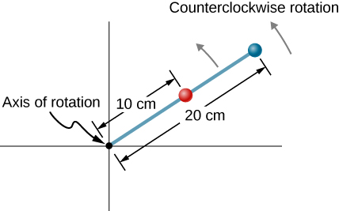

Solution

a. ; b. ;

c. ;

d. ;

e. 

1. A wheel has a constant angular acceleration of  Starting from rest, it turns through 300 rad. (a) What is its final angular velocity? (b) How much time elapses while it turns through the 300 radians?

Solution

a. ;

b. 

1. During a 6.0-s time interval, a flywheel with a constant angular acceleration turns through 500 radians that acquire an angular velocity of 100 rad/s. (a) What is the angular velocity at the beginning of the 6.0 s? (b) What is the angular acceleration of the flywheel?

Solution

a. ;

b. 

1. The angular velocity of a rotating rigid body increases from 500 to 1500 rev/min in 120 s. (a) What is the angular acceleration of the body? (b) Through what angle does it turn in this 120 s?

Solution

a. ;

b. 

1. A flywheel slows from 600 to 400 rev/min while rotating through 40 revolutions. (a) What is the angular acceleration of the flywheel? (b) How much time elapses during the 40 revolutions?

Solution

a. 

b. 

1. A wheel 1.0 m in radius rotates with an angular acceleration of  (a) If the wheel’s initial angular velocity is 2.0 rad/s, what is its angular velocity after 10 s? (b) Through what angle does it rotate in the 10-s interval? (c) What are the tangential speed and acceleration of a point on the rim of the wheel at the end of the 10-s interval?

Solution

a. ;

b. ;

c. 

1. A vertical wheel with a diameter of 50 cm starts from rest and rotates with a constant angular acceleration of  around a fixed axis through its center counterclockwise. (a) Where is the point that is initially at the bottom of the wheel at  (b) What is the point’s linear acceleration at this instant?

Solution

a. , 39.8 rev is 0.8(360) = 288 degrees from the bottom of the wheel counterclockwise;

b. 

1. A circular disk of radius 10 cm has a constant angular acceleration of  at  its angular velocity is 2.0 rad/s. (a) Determine the disk’s angular velocity at  (b) What is the angle it has rotated through during this time? (c) What is the tangential acceleration of a point on the disk at 

Solution

a. ;

b.  ;

c. 

1. The angular velocity vs. time for a fan on a hovercraft is shown below. (a) What is the angle through which the fan blades rotate in the first 8 seconds? (b) Verify your result using the kinematic equations.

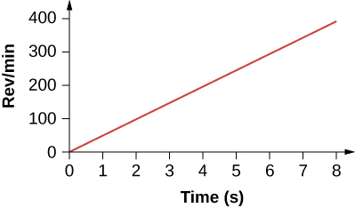

Solution

a. ,, area ;

b. ,

which is in agreement with (a)

1. A rod of length 20 cm has two bead attached its ends. The rod with beads starts rotating from rest. If the bead are to have a tangential speed of 20 m/s in 7 s, what is the angular acceleration of the rod to achieve this?

Solution

The angular velocity to achieve the tangential speed is :

.

1. At its peak, a tornado is 60.0 m in diameter and carries 500 km/h winds. What is its angular velocity in revolutions per second?

Solution



1. A man stands on a merry-go-round that is rotating at 2.5 rad/s. If the coefficient of static friction between the man’s shoes and the merry-go-round is  how far from the axis of rotation can he stand without sliding?

Solution

The merry-go-round is rotating at a constant angular velocity, so the angular acceleration is zero, leaving only the centripetal acceleration. For the man not to slide off, the force of friction must equal the centripetal acceleration times his mass.

 

1. An ultracentrifuge accelerates from rest to 100,000 rpm in 2.00 min. (a) What is the average angular acceleration in ? (b) What is the tangential acceleration of a point 9.50 cm from the axis of rotation? (c) What is the centripetal acceleration in  and multiples of *g* of this point at full rpm? (d) What is the total distance traveled during the acceleration by a point 9.5 cm from the axis of rotation of the ultracentrifuge?

Solution

a. ;

b. ;

c. 

d. 

1. A wind turbine is rotating counterclockwise at 0.5 rev/s and slows to a stop in 10 s. Its blades are 20 m in length. (a) What is the angular acceleration of the turbine? (b) What is the centripetal acceleration of the tip of the blades at  (c) What is the magnitude and direction of the total linear acceleration of the tip of the blade that lies along the positive *x*-axis at 

Solution

a. ,

b. ; c. 

 in the counterclockwise direction from the centripetal acceleration vector

1. What is (a) the angular speed and (b) the linear speed of a point on Earth’s surface at latitude  N. Take the radius of the Earth to be 6309 km. (c) At what latitude would your linear speed be 10 m/s?

Solution

a. The angular speed of Earth is ;

b. ;

c. 

1. A child with mass 40 kg sits on the edge of a merry-go-round at a distance of 3.0 m from its axis of rotation. The merry-go-round accelerates from rest up to 0.4 rev/s in 10 s. If the coefficient of static friction between the child and the surface of the merry-go-round is 0.6, does the child fall off before 5 s?

Solution

 At  the angular velocity is





The maximum friction force is  so the child does not fall of yet.

1. A bicycle wheel with radius 0.3m rotates from rest to 3 rev/s in 5 s. What is the magnitude and direction of the total acceleration vector at the edge of the wheel at 1.0 s?

Solution



Therefore,  The angle that the total acceleration vector makes with the centripetal acceleration vector is:  in the counterclockwise direction since the wheel is accelerating in that direction.

1. The angular velocity of a flywheel with radius 1.0 m varies according to  Plot  from  for  Analyze these results to explain when  and when  for a point on the flywheel at a radius of 1.0 m.

Solution



Plotting both accelerations gives

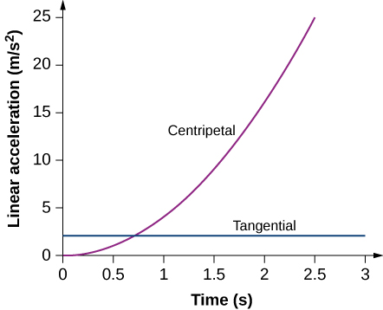

The tangential acceleration is constant, while the centripetal acceleration is time dependent, and increases with time to values much greater than the tangential acceleration after *t* = 1s. For times less than 0.7 s and approaching zero the centripetal acceleration is much less than the tangential acceleration.

1. A system of point particles is shown in the following figure. Each particle has mass 0.3 kg and they all lie in the same plane. (a) What is the moment of inertia of the system about the given axis? (b) If the system rotates at 5 rev/s, what is its rotational kinetic energy?

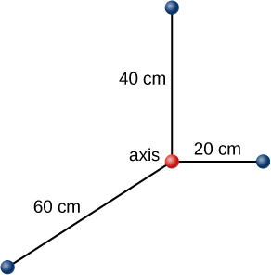

Solution

a. 

b. 

1. (a) Calculate the rotational kinetic energy of Earth on its axis. (b) What is the rotational kinetic energy of Earth in its orbit around the Sun?

Solution

a. 

b. 

1. Calculate the rotational kinetic energy of a 12-kg motorcycle wheel if its angular velocity is 120 rad/s and its inner radius is 0.280 m and outer radius 0.330 m.

Solution



1. A baseball pitcher throws the ball in a motion where there is rotation of the forearm about the elbow joint as well as other movements. If the linear velocity of the ball relative to the elbow joint is 20.0 m/s at a distance of 0.480 m from the joint and the moment of inertia of the forearm is , what is the rotational kinetic energy of the forearm?

Solution



1. A diver goes into a somersault during a dive by tucking her limbs. If her rotational kinetic energy is 100 J and her moment of inertia in the tuck is  what is her rotational rate during the somersault?

Solution



This means her rotation rate is about one revolution in 2 seconds. Usually divers can execute three or four spins per dive so in this case she would hit the water before completing the spins. Her rotational kinetic energy must be much larger than 100 J.

1. An aircraft is coming in for a landing at 300 meters height when the propeller falls off. The aircraft is flying at 40.0 m/s horizontally. The propeller has a rotation rate of 20 rev/s, a moment of inertia of 70.0 kg-m2, and a mass of 200 kg. Neglect air resistance. (a) With what translational velocity does the propeller hit the ground? (b) What is the rotation rate of the propeller at impact?

Solution

a. The initial energy in the system is 

The gravitational potential energy is converted into translational energy:



Since  the rotational terms cancel,



and we have 

;

b. The rotational rate of the propeller stays the same at 20 rev/s.

1. If air resistance is present in the preceding problem and reduces the propeller’s rotational kinetic energy at impact by 30%, what is the propeller’s rotation rate at impact?

Solution

The initial rotational kinetic energy of the propeller is The final energy is  

1. A neutron star of mass 2 × 1030 kg and radius 10 km rotates with a period of 0.02 seconds. What is its rotational kinetic energy?

Solution



1. An electric sander consisting of a rotating disk of mass 0.7 kg and radius 10 cm rotates at 15 rev/s. When applied to a rough wooden wall the rotation rate decreases by 20%. (a) What is the final rotational kinetic energy of the rotating disk? (b) How much has its rotational kinetic energy decreased?

Solution

a. ;

b. initial kinetic energy:

 decrease

1. A system consists of a disk of mass 2.0 kg and radius 50 cm upon which is mounted an annular cylinder of mass 1.0 kg with inner radius 20 cm and outer radius 30 cm (see below). The system rotates about an axis through the center of the disk and annular cylinder at 10 rev/s. (a) What is the moment of inertia of the system? (b) What is its rotational kinetic energy?

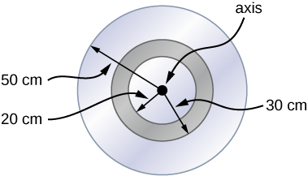

Solution

a. 

;

b. 

1. While punting a football, a kicker rotates his leg about the hip joint. The moment of inertia of the leg is  and its rotational kinetic energy is 175 J. (a) What is the angular velocity of the leg? (b) What is the velocity of tip of the punter’s shoe if it is 1.05 m from the hip joint?

Solution

a. ;

b. 

1. Using the parallel axis theorem, what is the moment of inertia of the rod of mass *m* about the axis shown below?

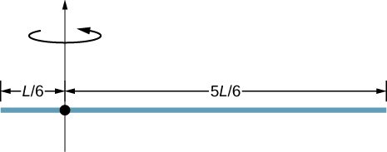

Solution

by the parallel-axis theorem



1. Find the moment of inertia of the rod in the previous problem by direct integration.

Solution



1. A uniform rod of mass 1.0 kg and length 2.0 m is free to rotate about one end (see the following figure). If the rod is released from rest at an angle of  with respect to the horizontal, what is the speed of the tip of the rod as it passes the horizontal position?

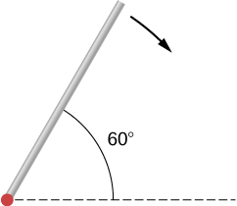

Solution

The center of mass of the rod is located  above the horizontal. By conservation of energy, ,

, and



1. A pendulum consists of a rod of mass 2 kg and length 1 m with a solid sphere at one end with mass 0.3 kg and radius 20 cm (see the following figure). If the pendulum is released from rest at an angle of  what is the angular velocity at the lowest point?

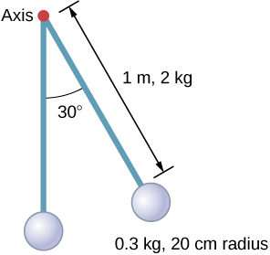

Solution

the center of mass of the system is located at  from the axis of rotation.

,

 and



1. A solid sphere of radius 10 cm is allowed to rotate freely about an axis. The sphere is given a sharp blow so that its center of mass starts from the position shown in the following figure with speed 15 cm/s. What is the maximum angle that the diameter makes with the vertical?

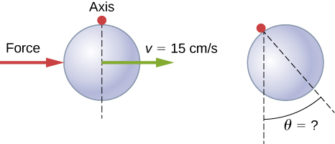

Solution



,



1. Calculate the moment of inertia by direct integration of a thin rod of mass *M* and length *L* about an axis through the rod at *L*/3, as shown below. Check your answer with the parallel-axis theorem.

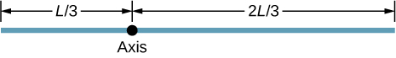

Solution

We take the origin at the axis of rotation. The linear mass density is: ,

  
by parallel axis theorem: 

1. Two flywheels of negligible mass and different radii are bonded together and rotate about a common axis (see below). The smaller flywheel of radius 30 cm has a cord that has a pulling force of 50 N on it. What pulling force needs to be applied to the cord connecting the larger flywheel of radius 50 cm such that the combination does not rotate?

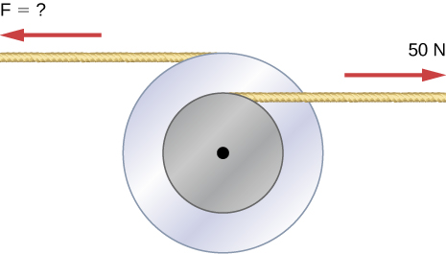

Solution

The torques must balance. 

1. The cylinder head bolts on a car are to be tightened with a torque of 62.0 Nm. If a mechanic uses a wrench of length 20 cm, what perpendicular force must he exert on the end of the wrench to tighten a bolt correctly?

Solution



1. (a) When opening a door, you push on it perpendicularly with a force of 55.0 N at a distance of 0.850 m from the hinges. What torque are you exerting relative to the hinges? (b) Does it matter if you push at the same height as the hinges? There is only one pair of hinges.

Solution

a. ; b. It does not matter at what height you push. The torque depends on only the magnitude of the force applied and the perpendicular distance of the force’s application from the hinges.

1. When tightening a bolt, you push perpendicularly on a wrench with a force of 165 N at a distance of 0.140 m from the center of the bolt. How much torque are you exerting in newton-meters (relative to the center of the bolt)?

Solution



1. What hanging mass must be placed on the cord to keep the pulley from rotating (see the following figure)? The mass on the frictionless plane is 5.0 kg. The mass on the plane is connected to a cord that wraps around the pulley’s inner radius of 20 cm. The hanging mass is connected to a cord that wraps around the pulley’s outer radius of 30 cm.

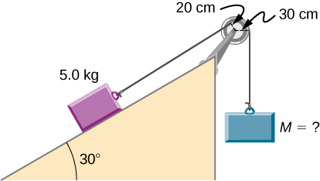

Solution

the mass on the plane provides a torque of 



1. A simple pendulum consists of a massless tether 50 cm in length connected to a pivot and a small mass of 1.0 kg attached at the other end. What is the torque about the pivot when the pendulum makes an angle of  with respect to the vertical?

Solution

The component of the gravitational force perpendicular to the lever arm is   
.

1. Calculate the torque about the z-axis that is out of the page at the origin in the following figure, given that 

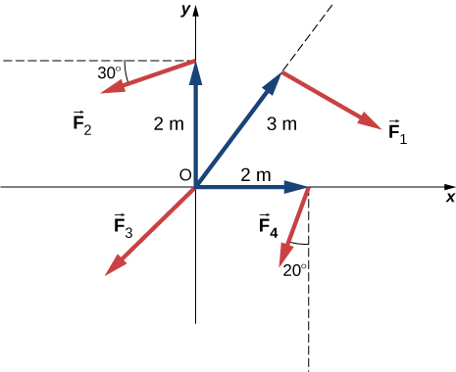

Solution



1. A seesaw has length 10.0 m and uniform mass 10.0 kg and is resting at an angle of  with respect to the ground (see the following figure). The pivot is located at 6.0 m. What magnitude of force needs to be applied perpendicular to the seesaw at the raised end so as to allow the seesaw to barely start to rotate?

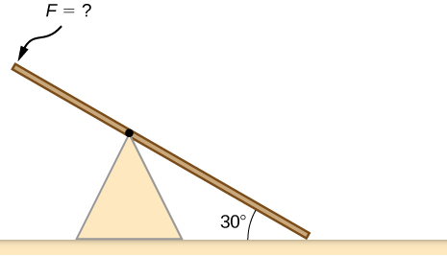

Solution

The seesaw has mass/length of 1 kg/m. The lower end has mass 6.0 kg and would provide a torque of  when slightly off the ground, where the lever arm is 3.0 m to the center of mass of the lower end. The upper end provides a torque of , where the lever arm is 2.0 m to the center of mass up the upper end. This means an additional torque of  is needed to balance . At the tip a force perpendicular to the seesaw to provide this torque is: 

1. A pendulum consists of a rod of mass 1 kg and length 1 m connected to a pivot with a solid sphere attached at the other end with mass 0.5 kg and radius 30 cm. What is the torque about the pivot when the pendulum makes an angle of  with respect to the vertical?

Solution

the center of mass of the system is located at  from the axis of rotation;



1. A torque of  is required to raise a drawbridge (see the following figure). What is the tension necessary to produce this torque? Would it be easier to raise the drawbridge if the angle  were larger or smaller?

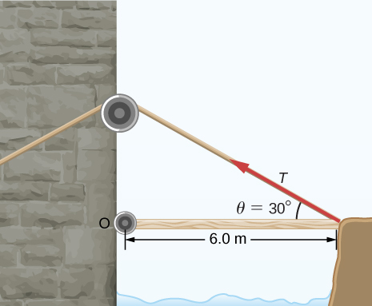

Solution



If  were larger, it would require less tension because the sin of the angle would increase.

1. A horizontal beam of length 3 m and mass 2.0 kg has a mass of 1.0 kg and width 0.2 m sitting at the end of the beam (see the following figure). What is the torque of the system about the support at the wall?

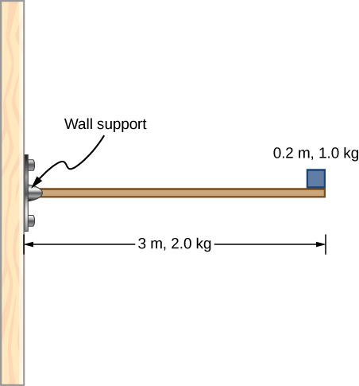

Solution



1. What force must be applied to end of a rod along the *x*-axis of length 2.0 m in order to produce a torque on the rod about the origin of ?

Solution



1. What is the torque about the origin of the force  if it is applied at the point whose position is: 

Solution



1. You have a grindstone (a disk) that is 90.0 kg, has a 0.340-m radius, and is turning at 90.0 rpm, and you press a steel axe against it with a radial force of 20.0 N. (a) Assuming the kinetic coefficient of friction between steel and stone is 0.20, calculate the angular acceleration of the grindstone. (b) How many turns will the stone make before coming to rest?

Solution

a. ;

b.  

1. Suppose you exert a force of 180 N tangential to a 0.280-m-radius, 75.0-kg grindstone (a solid disk). (a)What torque is exerted? (b) What is the angular acceleration assuming negligible opposing friction? (c) What is the angular acceleration if there is an opposing frictional force of 20.0 N exerted 1.50 cm from the axis?

Solution

a. ;

b. ;

c. 

1. A flywheel  starting from rest acquires an angular velocity of 200.0 rad/s while subject to a constant torque from a motor for 5 s. (a) What is the angular acceleration of the flywheel? (b) What is the magnitude of the torque?

Solution

a. ; b. 

1. A constant torque is applied to a rigid body whose moment of inertia is  around the axis of rotation. If the wheel starts from rest and attains an angular velocity of 20.0 rad/s in 10.0 s, what is the applied torque?

Solution



1. A torque of 50.0 N-m is applied to a grinding wheel  for 20 s. (a) If it starts from rest, what is the angular velocity of the grinding wheel after the torque is removed? (b) Through what angle does the wheel move while the torque is applied?

Solution

a. ;

b. 

1. A flywheel  rotating at 500.0 rev/min is brought to rest by friction in 2.0 min. What is the frictional torque on the flywheel?

Solution



1. A uniform cylindrical grinding wheel of mass 50.0 kg and diameter 1.0 m is turned on by an electric motor. The friction in the bearings is negligible. (a) What torque must be applied to the wheel to bring it from rest to 120 rev/min in 20 revolutions? (b) A tool whose coefficient of kinetic friction with the wheel is 0.60 is pressed perpendicularly against the wheel with a force of 40.0 N. What torque must be supplied by the motor to keep the wheel rotating at a constant angular velocity?

Solution

a. ,

;

b.  to keep the wheel at a constant angular velocity

1. Suppose when Earth was created, it was not rotating. However, after the application of a uniform torque for 6 days according to the current length of a day, it was rotating at 1 rev/day. (a) What was the angular acceleration during the 6 days? (b) What torque was applied to Earth during this period? (c) What force tangent to Earth at its equator would produce this torque?

Solution

a. ;

b. ; c. 

1. A pulley of moment of inertia  is mounted on a wall as shown in the following figure. Light strings are wrapped around two circumferences of the pulley and weights are attached. What are (a) the angular acceleration of the pulley and (b) the linear acceleration of the weights? Assume the following data: .

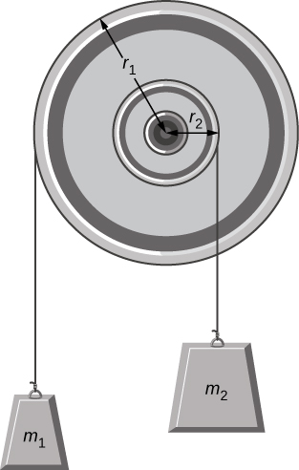

Solution

a.

;

b. 



1. A block of mass 3 kg slides down an inclined plane at an angle of  with a massless tether attached to a pulley with mass 1 kg and radius 0.5 m at the top of the incline (see the following figure). The pulley can be approximated as a disk. The coefficient of kinetic friction on the plane is 0.4. What is the acceleration of the block?

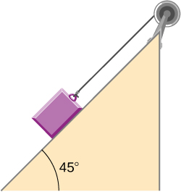

Solution

 from forces on the block, Newton’s second law  
 torque on the pulley =  since    
   


1. The cart shown below moves across the table top as the block falls. What is the acceleration of the cart? Neglect friction and assume the following data:

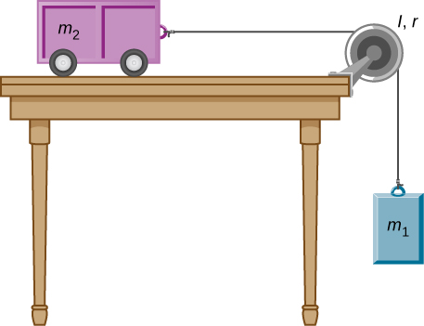

Solution

The difference in tensions gives the net torque on the pulley.

 



1. A uniform rod of mass and length is held vertically by two strings of negligible mass, as shown below. (a) Immediately after the string is cut, what is the linear acceleration of the free end of the stick? (b) Of the middle of the stick?

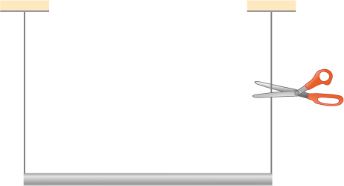

Solution

Torque is mg (distance to center of mass) from pivot at left string; a.

; b. 

1. A thin stick of mass 0.2 kg and length  is attached to the rim of a metal disk of mass  and radius The stick is free to rotate around a horizontal axis through its other end (see the following figure). (a) If the combination is released with the stick horizontal, what is the speed of the center of the disk when the stick is vertical? (b) What is the acceleration of the center of the disk at the instant the stick is released? (c) At the instant the stick passes through the vertical?

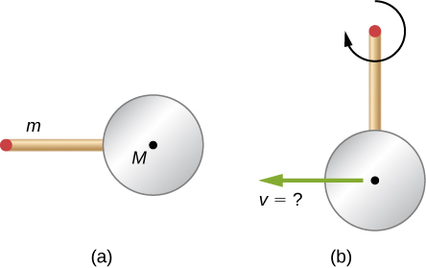

Solution

;

center of mass: ;

a. 

;   
speed of center of disk at vertical ;

b. torque at horizontal: ,

;

c. The torque on the system is zero so the acceleration is due only to the centripetal force: .

1. A wind turbine rotates at 20 rev/min. If its power output is 2.0 MW, what is the torque produced on the turbine from the wind?

Solution



1. A clay cylinder of radius 20 cm on a potter’s wheel spins at a constant rate of 10 rev/s. The potter applies a force of 10 N to the clay with his hands where the coefficient of friction is 0.1 between his hands and the clay. What is the power that the potter has to deliver to the wheel to keep it rotating at this constant rate?

Solution



1. A uniform cylindrical grindstone has a mass of 10 kg and a radius of 12 cm. (a) What is the rotational kinetic energy of the grindstone when it is rotating at  (b) After the grindstone’s motor is turned off, a knife blade is pressed against the outer edge of the grindstone with a perpendicular force of 5.0 N. The coefficient of kinetic friction between the grindstone and the blade is 0.80. Use the work energy theorem to determine how many turns the grindstone makes before it stops.

Solution

;

a. ;

b. 

1. A uniform disk of mass 500 kg and radius 0.25 m is mounted on frictionless bearings so it can rotate freely around a vertical axis through its center (see the following figure). A cord is wrapped around the rim of the disk and pulled with a force of 10 N. (a) How much work has the force done at the instant the disk has completed three revolutions, starting from rest? (b) Determine the torque due to the force, then calculate the work done by this torque at the instant the disk has completed three revolutions? (c) What is the angular velocity at that instant? (d) What is the power output of the force at that instant?

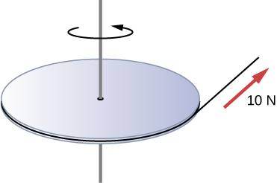

Solution

a. ;

b. ;

c. ;

d. 

1. A propeller is accelerated from rest to an angular velocity of 1000 rev/min over a period of 6.0 seconds by a constant torque of  (a) What is the moment of inertia of the propeller? (b) What power is being provided to the propeller 3.0 s after it starts rotating?

Solution

a. ;

b.

1. A sphere of mass 1.0 kg and radius 0.5 m is attached to the end of a massless rod of length 3.0 m. The rod rotates about an axis that is at the opposite end of the sphere (see below). The system rotates horizontally about the axis at a constant 400 rev/min. After rotating at this angular speed in a vacuum, air resistance is introduced and provides a force  on the sphere opposite to the direction of motion. What is the power provided by air resistance to the system 100.0 s after air resistance is introduced?

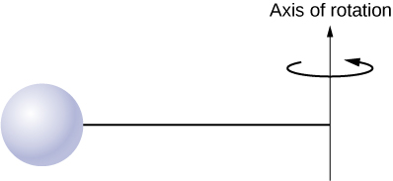

Solution

,







1. A uniform rod of length *L* and mass *M* is held vertically with one end resting on the floor as shown below. When the rod is released, it rotates around its lower end until it hits the floor. Assuming the lower end of the rod does not slip, what is the linear velocity of the upper end when it hits the floor?

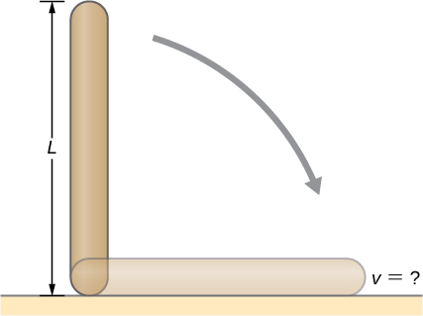

Solution

 is measured from the vertical. The torque is taken from the center of mass,  ;



1. An athlete in a gym applies a constant force of 50 N to the pedals of a bicycle at a rate of the pedals moving 60 rev/min. The length of the pedal arms is 30 cm. What is the power delivered to the bicycle by the athlete?

Solution

,



1. A 2-kg block on a frictionless inclined plane at  has a cord attached to a pulley of mass 1 kg and radius 20 cm (see the following figure). The block slides a distance of 0.50 m. (a) What is the acceleration of the block down the plane? (b) What is the work done by the cord on the pulley?

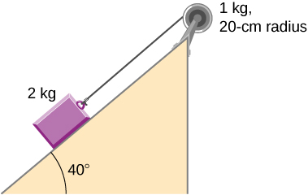

Solution

a. ,

,

,  that of a disk,

;

b. The net torque on the pulley: ,

,   


1. Small bodies of mass  are attached to opposite ends of a thin rigid rod of length *L* and mass *M*. The rod is mounted so that it is free to rotate in a horizontal plane around a vertical axis (see below). What distance *d* from  should the rotational axis be so that a minimum amount of work is required to set the rod rotating at an angular velocity 

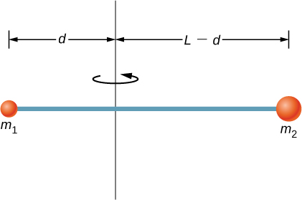

Solution

Minimum work means minimum moment of inertia since: . For the rod: 







**Additional Problems**

1. A cyclist is riding such that the wheels of the bicycle have a rotation rate of 3.0 rev/s. If the cyclist brakes such that the rotation rate of the wheels decrease at a rate of  how long does it take for the cyclist to come to a complete stop?

Solution



1. Calculate the angular velocity of the orbital motion of Earth around the Sun.

Solution



1. A phonograph turntable rotating at 33 1/3 rev/min slows down and stops in 1.0 min. (a) What is the turntable’s angular accelerating assuming it is constant? (b) How many revolutions does the turntable make while stopping?

Solution

a.  ; b. 

1. With the aid of a string, a gyroscope is accelerated from rest to 32 rad/s in 0.40 s under a constant angular acceleration. (a) What is its angular acceleration in ? (b) How many revolutions does it go through in the process?

Solution



b. 

1. Suppose a piece of dust has fallen on a CD. If the spin rate of the CD is 500 rpm, and the piece of dust is 4.3 cm from the center, what is the total distance traveled by the dust in 3 minutes? (Ignore accelerations due to getting the CD rotating.)

Solution





1. A system of point particles is rotating about a fixed axis at 4 rev/s. The particles are fixed with respect to each other. The masses and distances to the axis of the point particles are  . (a) What is the moment of inertia of the system? (b) What is the rotational kinetic energy of the system?

Solution

a. ;

b. 

1. Calculate the moment of inertia of a skater given the following information. (a) The 60.0-kg skater is approximated as a cylinder that has a 0.110-m radius. (b) The skater with arms extended is approximated by a cylinder that is 52.5 kg, has a 0.110-m radius, and has two 0.900-m-long arms which are 3.75 kg each and extend straight out from the cylinder like rods rotated about their ends.

Solution

a. ;

b. 

1. A stick of length 1.0 m and mass 6.0 kg is free to rotate about a horizontal axis through the center. Small bodies of masses 4.0 and 2.0 kg are attached to its two ends (see the following figure). The stick is released from the horizontal position. What is the angular velocity of the stick when it swings through the vertical?

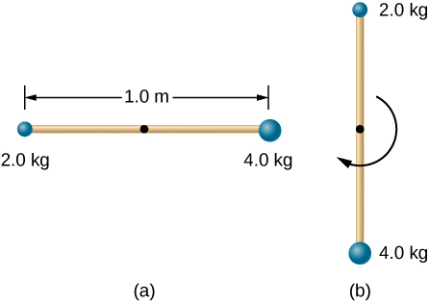

Solution

The center of mass of the system with respect to the axis of rotation:   
,

,

,



1. A pendulum consists of a rod of length 2 m and mass 3 kg with a solid sphere of mass 1 kg and radius 0.3 m attached at one end. The axis of rotation is as shown below. What is the angular velocity of the pendulum at its lowest point if it is released from rest at an angle of 

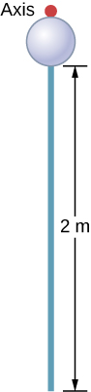

Solution

the center of mass of the system is located at  from the axis of rotation.







1. Calculate the torque of the 40-N force around the axis through *O* and perpendicular to the plane of the page as shown below.

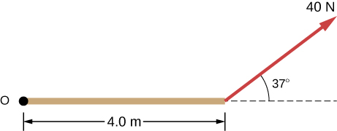

Solution



1. Two children push on opposite sides of a door during play. Both push horizontally and perpendicular to the door. One child pushes with a force of 17.5 N at a distance of 0.600 m from the hinges, and the second child pushes at a distance of 0.450 m. What force must the second child exert to keep the door from moving? Assume friction is negligible.

Solution



1. The force of  is applied at  What is the torque of this force about the origin?

Solution



1. An automobile engine can produce 200 Nm of torque. Calculate the angular acceleration produced if 95.0% of this torque is applied to the drive shaft, axle, and rear wheels of a car, given the following information. The car is suspended so that the wheels can turn freely. Each wheel acts like a 15.0-kg disk that has a 0.180-m radius. The walls of each tire act like a 2.00-kg annular ring that has inside radius of 0.180 m and outside radius of 0.320 m. The tread of each tire acts like a 10.0-kg hoop of radius 0.330 m. The 14.0-kg axle acts like a rod that has a 2.00-cm radius. The 30.0-kg drive shaft acts like a rod that has a 3.20-cm radius.

Solution



1. A grindstone with a mass of 50 kg and radius 0.8 m maintains a constant rotation rate of 4.0 rev/s by a motor while a knife is pressed against the edge with a force of 5.0 N. The coefficient of kinetic friction between the grindstone and the blade is 0.8. What is the power provided by the motor to keep the grindstone at the constant rotation rate?

Solution





**Challenge Problems**

1. The angular acceleration of a rotating rigid body is given by  If the body starts rotating from rest at  (a) what is the angular velocity? (b) Angular position? (c) What angle does it rotate through in 10 s? (d) Where does the vector perpendicular to the axis of rotation indicating  at  lie at ?

Solution

a. ;

b. ;

c. ;

d.  the vector is at 

1. Earth’s day has increased by 0.002 s in the last century. If this increase in Earth’s period is constant, how long will it take for Earth to come to rest?

Solution

The angular velocity of Earth is: .

The angular velocity in one century will be: ,

.

If the final angular velocity is zero, then

.

1. A disk of mass *m*, radius *R*, and area *A* has a surface mass density  (see the following figure). What is the moment of inertia of the disk about an axis through the center?

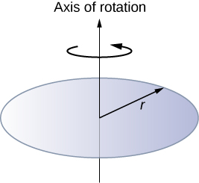

Solution



1. Zorch, an archenemy of Rotation Man, decides to slow Earth’s rotation to once per 28.0 h by exerting an opposing force at and parallel to the equator. Rotation Man is not immediately concerned, because he knows Zorch can only exert a force of  (a little greater than a Saturn V rocket’s thrust). How long must Zorch push with this force to accomplish his goal? (This period gives Rotation Man time to devote to other villains.)

Solution











Older than the age of the universe.

1. A cord is wrapped around the rim of a solid cylinder of radius 0.25 m, and a constant force of 40 N is exerted on the cord shown, as shown in the following figure. The cylinder is mounted on frictionless bearings, and its moment of inertia is . (a) Use the work energy theorem to calculate the angular velocity of the cylinder after 5.0 m of cord have been removed. (b) If the 40-N force is replaced by a 40-N weight, what is the angular velocity of the cylinder after 5.0 m of cord have unwound?

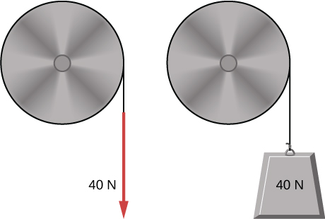

Solution

a. 



;

b. Use conservation of mechanical energy







This file is copyright 2016, Rice University. All Rights Reserved.